**Tables**

**Table 1.**

|  |  |  |
| --- | --- | --- |
| Table 1. Baseline characteristics for the Eurotransplant and UNOS regions | | |
|  | Eurotransplant | UNOS |
| study interval | 2007-2018 | 2016-2019 |
| n | 16,283 | 30,533 |
| Age (median (IQR)) | 55.0 [48.0, 61.0] | 58.0 [50.0, 64.0] |
| Gender male (%) | 10,796 (66.3) | 19,334 (63.3) |
| BMI (median (IQR)) | 25.6 [22.9, 29.2] | 29.0 [25.0, 33.0] |
| Disease (%) |  |  |
| Cirrhosis, Alcoholic | 6432 (39.5) | 9309 (30.5) |
| Cirrhosis, HCV | 1742 (10.7) | 4001 (13.1) |
| Cirrhosis, NASH | NA | 6328 (20.7) |
| Cirrhosis, other causes | 3794 (23.3) | 4754 (15.6) |
| Cholestatic disease | 1905 (11.7) | 2422 (7.9) |
| Other | 2410 (14.8) | 3725 (12.2) |
| Serum measurement at listing (mean (SD)) |  |  |
| Creatinine in mg/dL | 1.3 (3.0) | 1.5 (1.4) |
| Bilirubin in mg/dL | 6.0 (10.6) | 7.0 (9.4) |
| INR | 1.5 (0.6) | 1.8 (0.9) |
| Sodium in mmol/L | NA | 136 (5.0) |
| Dialysis dependency (%) | 937 (5.8) | 3223 (10.6) |
| MELD at listing (median(IQR)) | 15.0 [11.0, 21.0] | 18.0 [13.0, 26.0] |
| MELD-Na at listing (median(IQR)) | NA | 19.0 [12.0, 27.0] |
| Status at delisting (%) |  |  |
| Transplanted | 8174 (50.2) | 15928 (52.2) |
| Deceased | 3404 (20.9) | 3974 (13.0) |
| Removed from the waiting list | 3289 (20.2) | 9460 (31.0) |
| Censored at study end | 1417 (8.7) | 1171 (3.8) |
| NA: Eurotransplant has no complete data regarding this item | | |
| HCV: hepatitis-C induced, HCC: hepatocellular carcinoma,HU: high urgent status, | | |
| NSE: (non)standard exception points, MELD: Model of End-stage Liver Disease | | |

**Table 2.**

|  |  |  |  |  |  |  |  |
| --- | --- | --- | --- | --- | --- | --- | --- |
| 90-day mortality AUCs of the MELDNa-JM versus the MELD-Na, at baseline and during waiting list follow-up in the validation cohort. | | | | | | | |
| Time (months) | **MELDNa-JM** | low95 | upp95 | **MELD-Na** | low95 | upp95 | p |
| 0 | 0.91 | 0.89 | 0.93 | 0.84 | 0.81 | 0.87 | *** |
| 3 | 0.79 | 0.75 | 0.82 | 0.67 | 0.62 | 0.73 | *** |
| 6 | 0.80 | 0.76 | 0.84 | 0.69 | 0.61 | 0.75 | *** |
| 9 | 0.81 | 0.75 | 0.86 | 0.75 | 0.69 | 0.81 | *** |
| 12 | 0.74 | 0.66 | 0.81 | 0.69 | 0.58 | 0.79 | NS |
| 15 | 0.76 | 0.67 | 0.84 | 0.70 | 0.54 | 0.83 | *** |
| 18 | 0.78 | 0.69 | 0.86 | 0.76 | 0.62 | 0.87 | NS |
| 21 | 0.88 | 0.78 | 0.97 | 0.83 | 0.62 | 0.96 | NS |
| 24 | 0.72 | 0.60 | 0.85 | 0.68 | 0.42 | 0.86 | NS |
| *** p<0.001 | | | | | | | |
| AUC: area under receiver operator curve | | | | | | | |
| JM: joint model, MELD-Na: model for end-stage liver disease sodium score | | | | | | | |

**Table 3**

|  |  |  |  |  |  |
| --- | --- | --- | --- | --- | --- |
| Characteristics of prioritized recipients | | | | | |
|  | Both | MELDNa-JM prioritized | MELD-Na prioritized | Not prioritized | p |
| n | 3196 | 611 | 611 | 5658 |  |
| Age (median [IQR]) | 55.0 [47.0, 62.0] | 56.0 [48.0, 63.0] | 58.0 [51.0, 63.0] | 59.0 [53.0, 64.0] | <0.001 |
| Female sex (%) | 1209 (37.8) | 284 (46.5) | 216 (35.4) | 1978 (35.0) | <0.001 |
| BMI (mean (SD)) | 29.9 (6.6) | 28.5 (6.6) | 28.6 (5.8) | 29.1 (5.9) | <0.001 |
| Death within 90 days (%) | 498 (15.6) | 94 (15.4) | 26 (4.3) | 135 (2.4) | <0.001 |
| Disease (%) |  |  |  |  | <0.001 |
| Cirrhosis HCV | 235 (7.4) | 39 (6.4) | 87 (14.2) | 973 (17.2) |  |
| NASH | 597 (18.7) | 140 (22.9) | 138 (22.6) | 1204 (21.3) |  |
| Cirrhosis Alcoholic | 1413 (44.2) | 209 (34.2) | 230 (37.6) | 1245 (22.0) |  |
| Cirrhosis Other | 575 (18.0) | 108 (17.7) | 83 (13.6) | 761 (13.4) |  |
| Cholestatic disease | 185 (5.8) | 68 (11.1) | 33 (5.4) | 533 (9.4) |  |
| Metabolic disease | 73 (2.3) | 16 (2.6) | 13 (2.1) | 107 (1.9) |  |
| Malignant/benign tumor | 52 (1.6) | 12 (2.0) | 22 (3.6) | 705 (12.5) |  |
| Other | 66 (2.1) | 19 (3.1) | 5 (0.8) | 130 (2.3) |  |
| MELD (median [IQR]) | 30.0 [26.0, 37.0] | 21.0 [18.0, 24.0] | 22.0 [19.0, 24.0] | 14.0 [10.0, 17.0] | <0.001 |
| MELD-Na (median [IQR]) | 31.0 [27.0, 35.0] | 21.0 [19.0, 22.0] | 25.0 [24.0, 27.0] | 13.0 [9.0, 17.0] | <0.001 |

**Figure legends**

1. Two hypothetical patient trajectories on the LT waiting list are shown. Patient A initially increases and then stabilizes in disease severity. B is initially stable and later deteriorates. Under the current MELD(-Na) allocation, patient A would be prioritized over patient B in liver allocation, because the most recent MELD(-Na) is used. However, the JM uses both the past and current disease severity (value) and the rate of change at each moment in time (slope). At any given time, the JM combines the hazard ratio’s for value and slope to calculate the risk of death. Thus, the JM would calculate a higher mortality risk and thus LT priority for patient B, because the disease is increasing fast.
   1. 90-day mortality ROC plot of the MELDNa-JM and MELD-Na.
   2. Calibration plot of the MELDNa-JM and MELD-Na score. Each dot represents 10% of the population. The lines show how well the predicted risks match the observed risks.
2. The MELDNa-JM and MELD-Na would prioritize different patients for liver transplantation. For these patients, we plotted the individual (black lines) and average (red line) MELD-Na score development during 90 days. Although the MELD-Na-prioritized patients had a higher initial MELD-Na score (value), their average scores remained stable (slope). In contrast, the JM prioritized patients had lower MELD-Na (value) scores but with faster increasing disease severity (slope). Interestingly, the JM-prioritized patients had a five times higher 90-day mortality rate. Indicating that JM prioritization could possibly be more just.

**Figure 1**

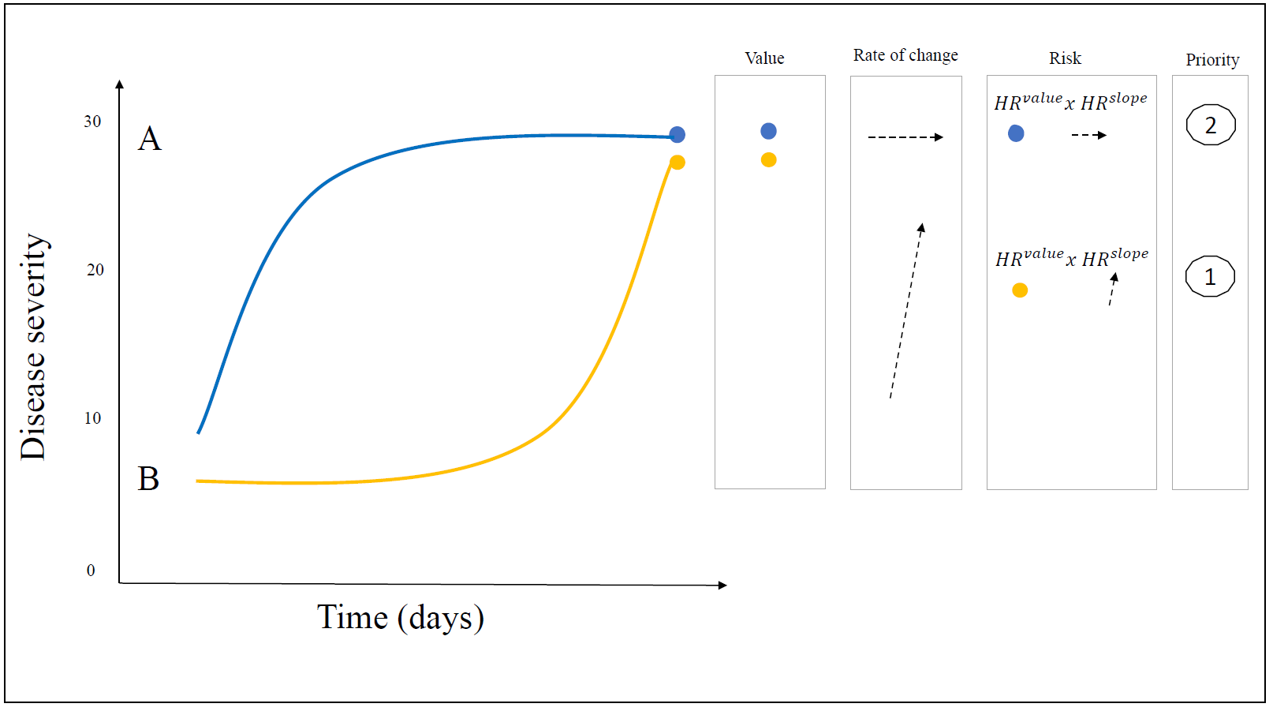

**Figure 2 A: ROC plot of MELDNa-JM vs MELD-Na**

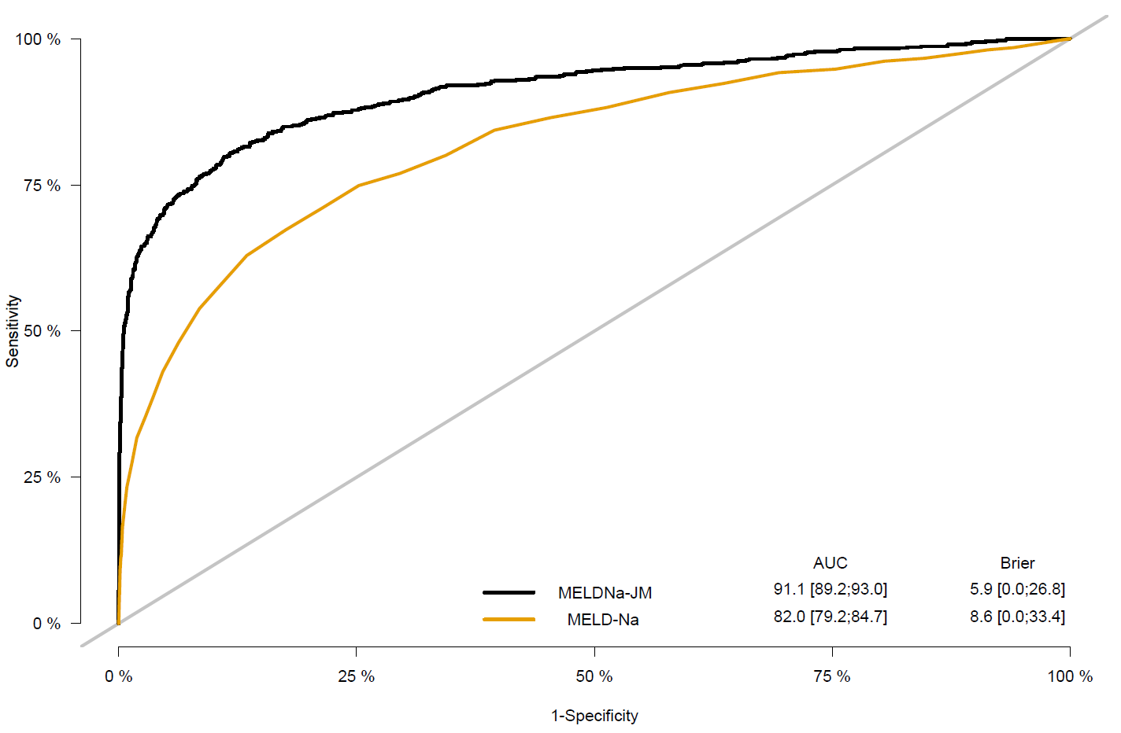

**Figure 2 B: calibration plot of MELDNa-JM versus MELD-Na**

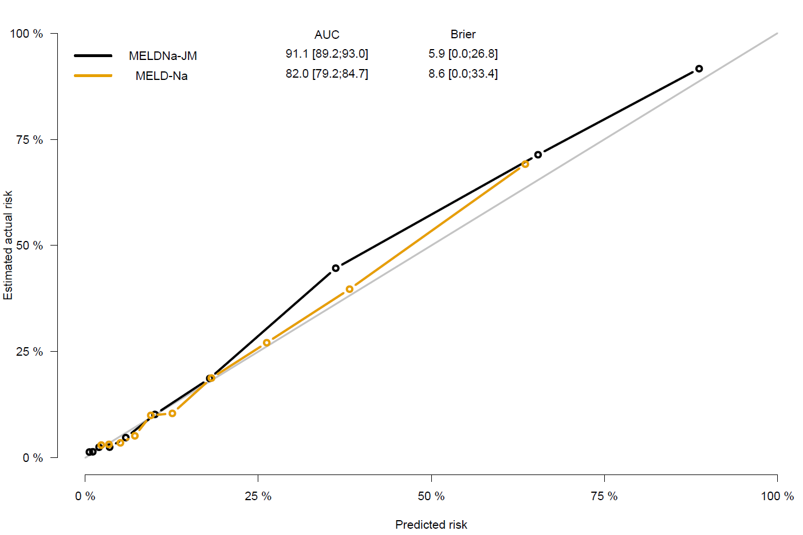

**Figure 3**

